**Computer System Operation**

The occurrence of an event is usually signaled by an **interrupt** from either the hardware or the software. Hardware may trigger an **interrupt** at any time by sending a signal to the CPU, usually by way of the system bus. Software may trigger an interrupt by executing a special operation called a **system call** (also called a **monitor call**). When the CPU is interrupted, it stops what it is doing and immediately transfer execution to a fixed location.

An interrupt is a signal from a device attached to a computer or from a program within the computer that requires the [operating system](https://whatis.techtarget.com/definition/operating-system-OS) to stop and figure out what to do next. Almost all personal (or larger) computers today are interrupt-driven - that is, they start down the list of computer [instructions](https://whatis.techtarget.com/definition/instruction) in one program (perhaps an application such as a word processor) and keep running the instructions until either (A) they can't go any further or (B) an interrupt signal is sensed. After the interrupt signal is sensed, the computer either resumes running the current program or begins running another program.

Basically, a single computer can perform only one computer instruction at a time. But, because it can be interrupted, it can take turns in which programs or sets of instructions that it performs. This is known as [multitasking](https://whatis.techtarget.com/definition/multitasking). It allows the user to do a number of different things at the same time. The computer simply takes turns managing the programs that the user starts. Of course, the computer operates at speeds that make it seem as though all of the user's tasks are being performed at the same time. (The computer's operating system is good at using little pauses in operations and user thinks time to work on other programs.)

In general, there are hardware interrupts and software interrupts. A hardware interrupt occurs, for example, when an I/O operation is completed such as reading some data into the computer from a tape drive. A software interrupt occurs when an application program terminates or requests certain services from the operating system. In a personal computer, a hardware interrupt request ([IRQ](https://whatis.techtarget.com/definition/IRQ-interrupt-request)) has a value that associates it with a particular device.

An operating system usually has some code that is called an interrupt handler. The interrupt handler prioritizes the interrupts and saves them in a [queue](https://whatis.techtarget.com/definition/queue) if more than one is waiting to be handled. The operating system has another little program, sometimes called a [scheduler](https://whatis.techtarget.com/definition/queue) that figures out which program to give control to next.

**Computer System Architecture**

1. Single processor System
2. Multiprocessor system
3. Clustered system

**Single Processor System**

A single processor system contains only one processor. So only one process can be executed at a time and then the process is selected from the ready queue. Most general purpose computers contain the single processor systems as they are commonly in use.

A single processor system can be further described using the diagram below:

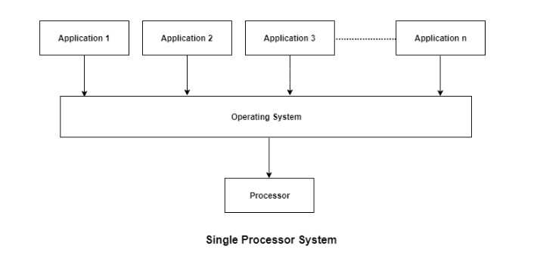

As in the above diagram, there are multiple applications that need to be executed. However, the system contains a single processor and only one process can be executed at a time.

**Multiprocessor systems**

Multiprocessor systems (also known as parallel or tightly coupled system) with more than one CPU in close communication. Here, processors share memory and a clock; communication usually takes place through the shared bus.

Advantages of parallel system:

* Increased reliability: If functions can be distributed properly among several processors, then the failure of one processor will not halt the system, only slow it down.
* Increased throughput: By increasing the no. of processors, we expect to get more work done in less time.
* Economical: Multiprocessor systems can cost less than equivalent multiple single processor system because they can share peripherals, mass storage and power supplies.

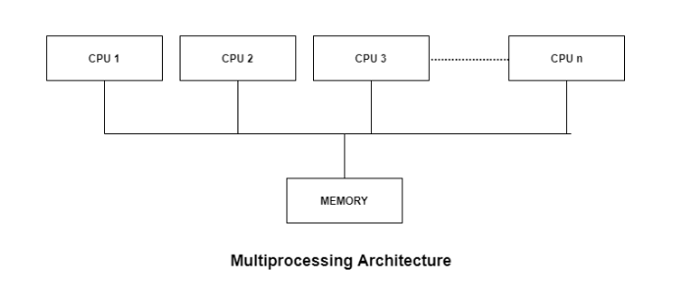

**Multiprocessor Systems (Types)**

* **Symmetric multiprocessing (SMP):** Each processor runs an identical copy of the operating system and these copies communicate with one another as needed.All processors are peers; no master-slave relationship exists between processors.Most modern operating systems support SMP
* **Asymmetric multiprocessing:** Each processor is assigned a specific task; master processor schedules and allocates work to slave processors.More common in extremely large systems

**Clustered System**

Clustered systems are similar to parallel systems as they both have multiple CPUs. However a major difference is that clustered systems are created by two or more individual computer systems merged together. Basically, they have independent computer systems with a common storage and the systems work together.

The clustered systems are a combination of hardware clusters and software clusters. The hardware clusters help in sharing of high performance disks between the systems. The software clusters makes all the systems work together.

Each node in the clustered systems contains the cluster software. This software monitors the cluster system and makes sure it is working as required. If any one of the nodes in the clustered system fail, then the rest of the nodes take control of its storage and resources and try to restart.

**Clustered System (Types)**

* **Asymmetric Clustering:** In this system, one of the nodes in the clustered system is in hot standby mode and all the others run the required applications. The hot standby mode is a failsafe in which a hot standby node is part of the system. The hot standby node continuously monitors the server and if it fails, the hot standby node takes its place.
* **Symmetric Clustering:** In symmetric clustering system two or more nodes all run applications as well as monitor each other. This is more efficient than asymmetric system as it uses all the hardware and doesn't keep a node merely as a hot standby.

A diagram to better illustrate this is:

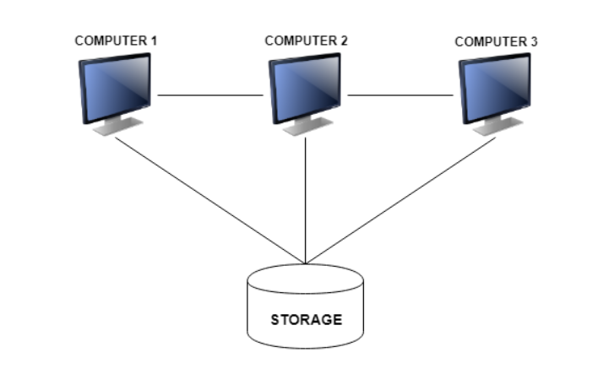

**Dual-Mode Operation**

* **Dual-mode** operation allows OS to protect it and other system components.
* **User mode** and **kernel mode**
* **Mode bit** provided by hardware
* Provides ability to distinguish when system is running user mode (mode1) or kernel mode (mode 0)
* When the computer system is executing on behalf of a user application, the system is in user mode.
* When a user application request a service from the operating system (via a system call), it must transition from user to kernel mode to fulfill the request.
* Some instructions designated as **privileged**, only executable in kernel mode. If an attempt is made to execute a privileged instruction in user mode, the hardware treats is as illegal and traps it to the OS.

**Transition from User to Kernel Mode**

At system boot time the hardware starts in kernel mode. The OS is then loaded and starts user applications in user mode. Whenever a trap or interrupt occurs, the hardware switches from user mode to kernel mode. Whenever the OS gains control of the computer, it is in kernel mode. The system always switches to user mode (by setting the mode bit to 1) before passing control to a user program. Eventually, control is switched back to the operating system via an interrupt, a trap or a system call.

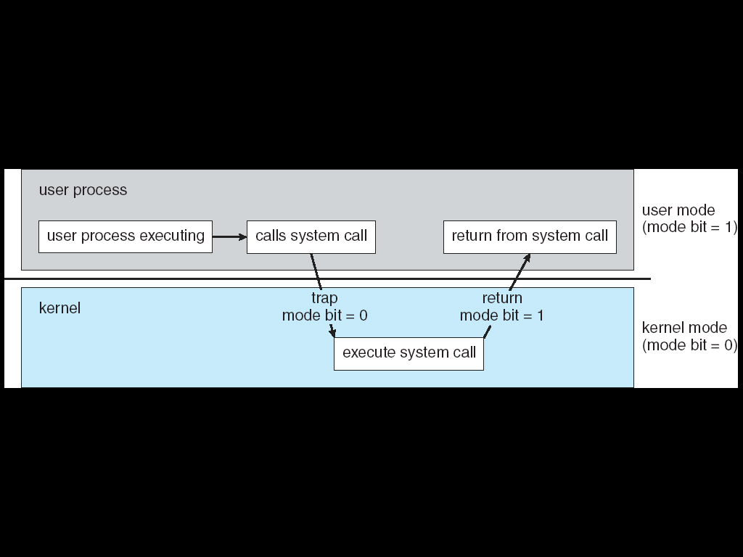

**Distributed System**

* A distributed system is a collection of physically separated, possibly heterogeneous computer system that is networked to provide the users with access to the various resources that the system maintains.
* Access to the shared resources increases computational speed, functionality, data availability and reliability.
* Distributed systems depend on networking for their functionality.

**Client Server Computing**

In client server computing, the client requests a resource and the server provides that resource. A server may serve multiple clients at the same time while a client is in contact with only one server. Both the client and server usually communicate via a computer network but sometimes they may reside in the same system.

An illustration of the client server system is given as follows:

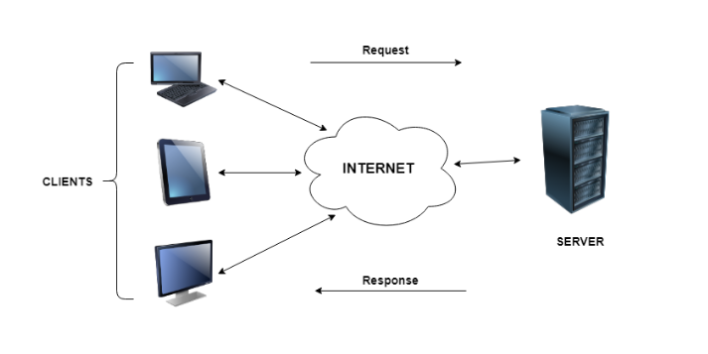

**Characteristics of Client Server Computing**

The salient points for client server computing are as follows:

* The client server computing works with a system of request and response. The client sends a request to the server and the server responds with the desired information.
* The client and server should follow a common communication protocol so they can easily interact with each other. All the communication protocols are available at the application layer.
* A server can only accommodate a limited number of client requests at a time. So it uses a system based to priority to respond to the requests.
* An example of a client server computing system is a web server. It returns the web pages to the clients that requested them.

**Peer-to-Peer Computing**

The peer to peer computing architecture contains nodes that are equal participants in data sharing. All the tasks are equally divided between all the nodes. The nodes interact with each other as required as share resources.

A diagram to better understand peer to peer computing is as follows:

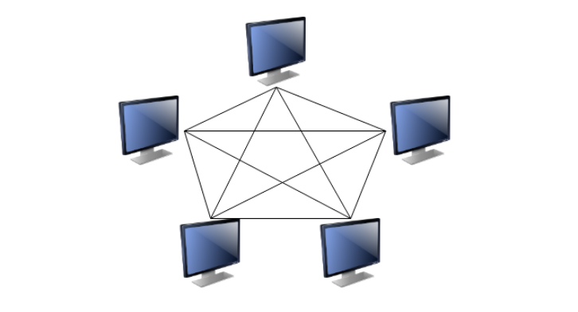

**Characteristics of Peer to Peer Computing**

The different characteristics of peer to peer networks are as follows:

* Peer to peer networks are usually formed by groups of a dozen or less computers. These computers all store their data using individual security but also share data with all the other nodes.
* The nodes in peer to peer networks both use resources and provide resources. So, if the nodes increase, then the resource sharing capacity of the peer to peer network increases. This is different than client server networks where the server gets overwhelmed if the nodes increase.
* Since nodes in peer to peer networks act as both clients and servers, it is difficult to provide adequate security for the nodes. This can lead to denial of service attacks.
* Most modern operating systems such as Windows and Mac OS contain software to implement peer to peer networks.